OHIO ATLATL ASSOCIATION “THE DART” APRIL 2026

A publication of the Ohio Atlatl Association ohioatlatl@hotmail.com
OHIO ATLATL ASSOCIATION
2026 EVENTS SCHEDULE
Please check the WAA Events Calendar for current information: www.worldatlatl.org. ISAC and Ohio Atlatl Association Accuracy Competitions conducted at all events. Additional events may be added later in the year.
May 2 – Atlatl Warm-Up: Deb’s House, 2041 Reynold Ave., Albany, OH 45701. ISAC and Ohio Locals. 10 am – noon or thereabouts. Contact deb_andrews@frontier.com for more information.
May 16 - Atlatl Warm-Up #2 : Deb’s House, 2041 Reynold Ave., Albany, OH 45701. ISAC and Ohio Locals. 10 am – noon or thereabouts. Contact deb_andrews@frontier.com for more information.
May 22-24 Spring Gem Show and Knap-In: Coshocton County Fairgrounds, 707 Kenilworth Drive, Coshocton, OH 43812. Fri/Sat 9am-5pm, Sun 9am-2pm. Contact Ray Strischek for more information at ohioatlatl@hotmail.com 740-331-4351 or Steve Barnett atlatlbarnz@gmail.com.
June 6 – World Atlatl Day: Athens Library, Home Street, Athens, OH 45701. Contact Ray Strischek for more information at ohioatlatl@hotmail.com 740-331-4351 or Steve Barnett atlatlbarnz@gmail.com.
June 19-21 – Meadowcroft: Meadowcroft Rockshelter and Historic Village, 401 Meadowcroft Rd., Avella PA 15312. Noon Friday to noon Sunday. Contact Andrew R. Donovan ardonovan@heinzhistorycenter.org. 724-587-3142 ext. 6053 for more information. Pot luck dinner Saturday evening. Snacks & drinks available in gift shop.
June 19-21 – Serpent Mound Summer Solstice Celebration. Soaring Eagle Retreat next to the Serpent Mound. Friday 3pm – 6-pm, Saturday & Sunday 10 am – 7 pm. Camping is available to those who pre-register with Ray Strischek ohioatlatl@hotmail.com or 740-331-4351. Go to http://www.serpentmound.org for more information. Activities provided at Serpent Mound and festival are free to the public.
June 27 – Atlatl Day Camp: Athens Library, Home Street, Athens, OH 45701. Contact Ray Strischek for more information at ohioatlatl@hotmail.com 740-331-4351 or Steve Barnett atlatlbarnz@gmail.com.
July 17-19: Michael Lester Memorial Atlatl Contest, held at Steve Barnett’s property 33399 Myers Rd., Pomeroy, OH 45679. Friday 2:00 pm until dark, Sat & Sun 10 AM to completion. Contact Ray Strischek for more information at ohioatlatl@hotmail.com 740-331-4351 or Steve Barnett atlatlbarnz@gmail.com.
July 24-26: The Janet Hall Memorial Atlatl Contest. Tim Hall’s property, 8111 Georgetown Rd., Indianapolis, IN 46268. Contact Tim Hall thcustom@sbcglobal.net, 317-627-5693 for more information.
August 7-9: 27th Annual That Dam ISAC Weekend held at Steve Barnett’s property 33399 Myers Rd., Pomeroy, OH 45679. Friday 2:00 pm until dark, Sat & Sun 10 AM to completion. Contact Ray Strischek for more information at ohioatlatl@hotmail.com 740-331-4351 or Steve Barnett atlatlbarnz@gmail.com.
August 21-23: Constance B. Harse Memorial Atlatl Contest, held at Steve Barnett’s property 33399 Myers Rd., Pomeroy, OH 45679. Friday 2:00 pm until dark, Sat & Sun 10 AM to completion. Contact Ray Strischek for more information at ohioatlatl@hotmail.com 740-331-4351 or Steve Barnett atlatlbarnz@gmail.com.
Sept. 4-6: Lithic Society Knap-In at Coshocton County Fairgrounds, 707 Kenilworth Dr., Coshocton, OH 43812. Contact Ray Strischek for more information at ohioatlatl@hotmail.com 740-331-4351 or Steve Barnett atlatlbarnz@gmail.com.
Sept. 18-20: 28th Annual PawPaw Festival, Lake Snowden, Albany, OH 45710. Contact Ray Strischek for more information at ohioatlatl@hotmail.com 740-331-4351 or Steve Barnett atlatlbarnz@gmail.com. See the website at https://www.ohiopawpawfest.com for more information and description of event.
Sept. 25-27: Indianapolis Autumn Event. Tim Hall’s property, 8111 Georgetown Rd., Indianapolis, IN 46268. Contact Tim Hall thcustom@sbcglobal.net, 317-627-5693 for more information.
Oct. 2-4: Indian Mounds Festival, The Community Park on Connett Road, The Plains, Ohio. Contact Ray Strischek for more information at ohioatlatl@hotmail.com 740-331-4351 or Steve Barnett atlatlbarnz@gmail.com. 10 am until finished on Sunday.
Oct. 9-11 Hocking Hills Knapp-In. View www.hocking-hills-knapp-in.com for information about the event, or contact Fletcher Wilson fletcherwilson@twc.com 740-279-9995. OAA will provide instruction and contests Friday, Saturday and Sunday morning. For info regarding the atlatl, Contact Ray Strischek ohioatlatl@hotmail.com 740-331-4351 or Steve Barnett atlatlbarnz@gmail.com.
Oct 17 – Almost Over Event: Deb’s House, 2041 Reynold Ave., Albany, OH 45701. ISAC and Ohio Locals. 10 am – noon or thereabouts. Contact deb_andrews@frontier.com for more information.
Oct. 30-31 – Ohio ROAR Days, at Hope School House, Zaleski State Forest/Lake Hope State Park, located at 27331 SR 278, McArthur, OH. 45651. Set up occurs Friday afternoon with ISAC and Ohio Locals, and all-day Saturday from 9am-4:pm. Contact Ray Strischek for more information at ohioatlatl@hotmail.com 740-331-4351 or Steve Barnett atlatlbarnz@gmail.com.
Please note that Serpent Mound and Meadowcroft both take place on the same weekend. OAA intends to have people at both events.
OAA will hold Ohio and ISAC accuracy competitions at all our events.
At the Athens Public Library, Spring Gem Show at Coshocton Fair Grounds, Serpent Mound, Laborday Weekend Flint Knapping Event at Coshocton Fair Grounds, Paw Paw Festival, The Plains Ohio Mound Festival, Hocking Hills Flint Knapping Event, and Roar, OAA will provide atlatl and darts and targets for teaching the use of the atlatl and dart to the visiting public for free.

MAP OF MOUND BUILDING IN NORTH AMERICA
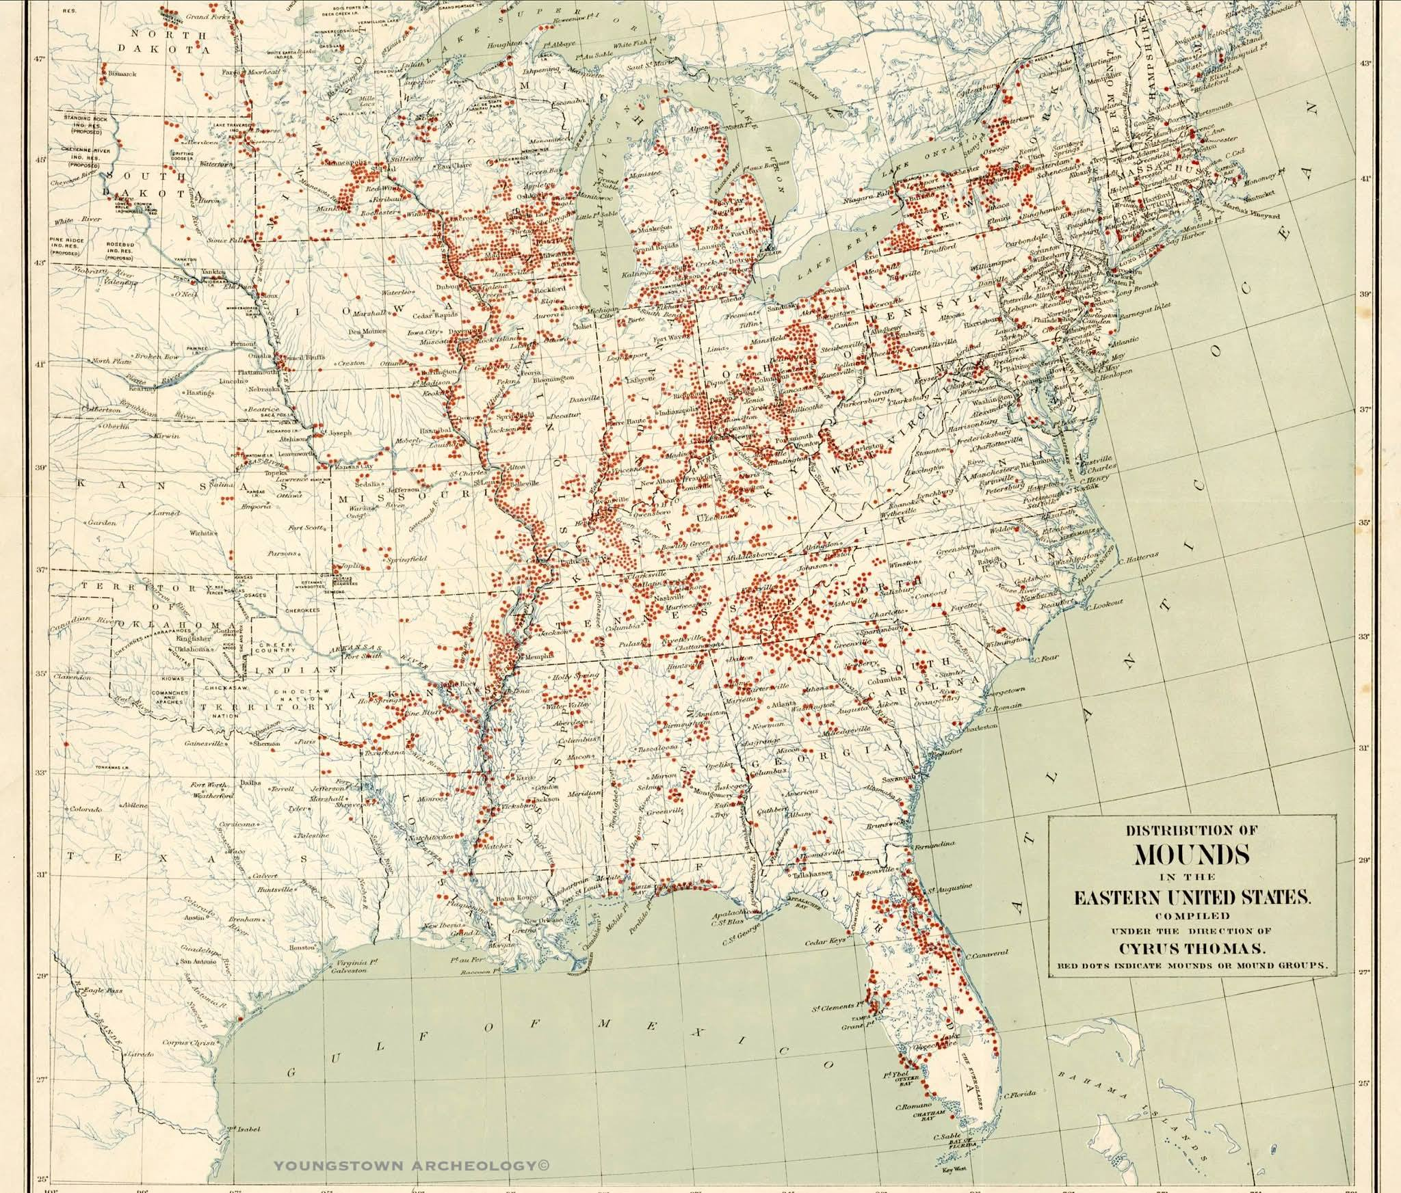

3000 BCE to 1500 CE
Mound Building in the USA
The timeline for mound building in the USA spans from approximately 3000 BCE to 1500 CE, with the earliest known mound complex, Watson Brake, constructed around 3500 BCE. The Mound Builders were advanced Native American societies that constructed impressive earthen mounds as ceremonial and burial sites. The Adena culture emerged around 200-500 AD in the Ohio River Valley and is considered one of the earliest mound-building cultures in North America. The Mississippian culture, which thrived from 700 to 1200 AD, is known for its impressive earthwork architecture, including the famous Cahokia in Illinois. The reasons for the decline of the Mound Builders are still debated, but factors such as environmental changes, warfare, and social upheaval likely played a role.
Adoption Of Bow Use In Ancient Hunting May Have Set Off Societal Changes
At a point during human prehistory, hunters' reliance on the spear-thrower, or atlatl, shifted to another kind of weapon — the self-bow.
This change happened on multiple continents (though bows never really caught on in Australia, where atlatls tended to yield only later, to firearms).
The first bows we know of conclusively, from archaeology, come from pine arrow shafts found at a bog site in Germany called Stellmoor, dating to around 11,000 years ago. Though, it's possible bows were in use much earlier in Africa.
Why did the bow replace the atlatl, and what social consequences may have followed from that shift? These are questions being asked by University of Wyoming PhD candidate in anthropology Brigid Sky Grund in a new paper in American Anthropologist, from which I took the above information.
As Grund notes in the article, most theories about this shift have pointed to the bow's greater accuracy and faster reload rate in hunting smaller fauna or in warfare. But Grund herself is looking instead at a different factor: the comparative learnability of each weapon. She writes:
"Most studies of bow and atlatl performance characteristics focus on the inherent qualities of the weapons themselves, neglecting to consider that functional weapons are wielded by capable individuals of various ages, sexes, strengths, dexterities, and skill levels."
I like this insight, because it puts people, in all our formidable variation, back into the equation, front and center. It's a dynamic-systems analysis if you will, in which a weapon and its user are inseparable.
In her analysis of learnability, Grund uses modern-day, long-term data sets — up to eight years' worth — from competitors participating in the World Atlatl Association International Standard Accuracy Contest (ISAC) and the Society for Creative Anachronism Inter-Kingdom Archery Competition (IAC).
Because she was able to track individual competitors' scores over time, she could see something about the rapidity of the learning curve for each weapon. As it turned out, individuals' atlatl scores increase rapidly right from the start, whereas people's bow scores don't — in fact only in the fourth year of competition do bow users begin to approach maximum skill level.
In addition, youth scores from the two competitions, taken together with anthropological data on real-world hunting-weapon use, show that "biological constraints may preclude juveniles from wielding bows until later ages than atlatls."
Grund thinks, then, that less strong weapon users in the past — based on contemporary differences in strength and dexterity in men and women, this group was likely to have included some women as well as juveniles — may have been more likely to learn how to use an atlatl effectively. The stronger, skilled members of a population would, then, be the ones more likely to readily learn how to use a bow successfully.
In an email message last week, Grund elaborated on this point:
"If entire family groups comprised of people of varying ages, sexes, and strengths wield projectile technologies as part of hunting parties, atlatls may be favored over bows because they are accessible to wider segments of human populations.
On the other hand, if only a few individuals from a family or cultural group are required to participate in hunting behavior, then the exclusivity of bow technology might not matter, since projectiles would only be wielded by a few hunting specialists within that group."
It's that line of reasoning that leads Grund straight into the realm of prehistoric social behavior. In her paper, she concludes that the bow's favoring of highly skilled weapon users probably "exacerbated prehistoric social disparities and likely catalyzed emergent age- and-sex-based social divisions in prehistory."
If she's right, that's a broadly important finding in anthropology, because it clues us in to a cascade of major social changes in human groups over time.
But what about our why question: Why the shift from an easier-to-use to a harder-to-use hunting weapon?
Echoing the behavioral-ecology perspective in her paper, Grund said (excerpted from a lengthier answer):
"Chronologically, in many regions of the world, the adoption of bow technology seems to be coarsely correlated with a broadening of diet breadth and an increased preponderance of small game hunting.
Many human behavioral ecology studies of modern foragers have shown that under broad diet breadth and/or high resource stress conditions, the sexual division of labor increases. Therefore, a shift towards hunting smaller game under many prehistoric scenarios was likely associated with an increase in the division of labor, simply as a product of fluctuating resource exploitation strategies and dietary needs."
As she continues, Grund explains more precisely where the atlatl-to-bow shift comes in:
"Increased divisions of labor associated with broadened diet breadth and the appearance of hunting 'specialists' might cause a shift from atlatl to bow technology, and, reciprocally, the adoption of bow technology might inherently intensify emergent divisions of labor since it is less accessible to people of varying ages, sexes, strengths, and/or dexterities.
Though I haven't disentangled cause and effect yet, it seems that both the shift from atlatl to bow and chronologically associated fluctuations in resource exploitation strategies likely worked together to increase divisions of labor in prehistoric societies."
An acknowledgment that cause and effect can't easily be distinguished in this case is welcome. Still, I think Grund is on to something by thinking broadly about generalists versus specialists in weapon use.
In our prehistory, at certain times and places, individuals became more specialized for certain tasks that others in the group couldn't, or didn't, carry out — and this in turn set social changes into effect. Precisely how human groups might be affected by the exclusion of certain group members from effective use of hunting technology such as bows may vary by region and will require new hypotheses and further work.
While discussing all this, I learned that for Grund, atlatls aren't merely academic. She threw her first atlatl dart back in high school, continued to experiment with atlatls during archaeology fieldwork, and in 2011 took first place in the novice/"non-regular competitor" women's division of an informal atlatl competition organized by the World Atlatl Association and the Wyoming Archaeological Society.
"We shot at homemade Pleistocene animal targets, including a paper mâché mammoth," Grund explained.
That paper mâché mammoth isn't credited in Grund's American Anthropologist paper. But who knows? Grund's hands-on experience may have played a role in her coming up with an innovative hypothesis about hunting patterns in our past.
Barbara J. King is an anthropology professor emerita at the College of William and Mary. She often writes about the cognition, emotion and welfare of animals, and about biological anthropology, human evolution and gender issues. Barbara's new book is Personalities on the Plate: The Lives and Minds of Animals We Eat. You can keep up with what she is thinking on Twitter: @bjkingape
